**Bydd angen mewngofnodi i Hwb a dewis Just2easy er mwyn cael mynediad i jit5.**

**To access jit5 you will need to log into Hwb and choose J2easy.**

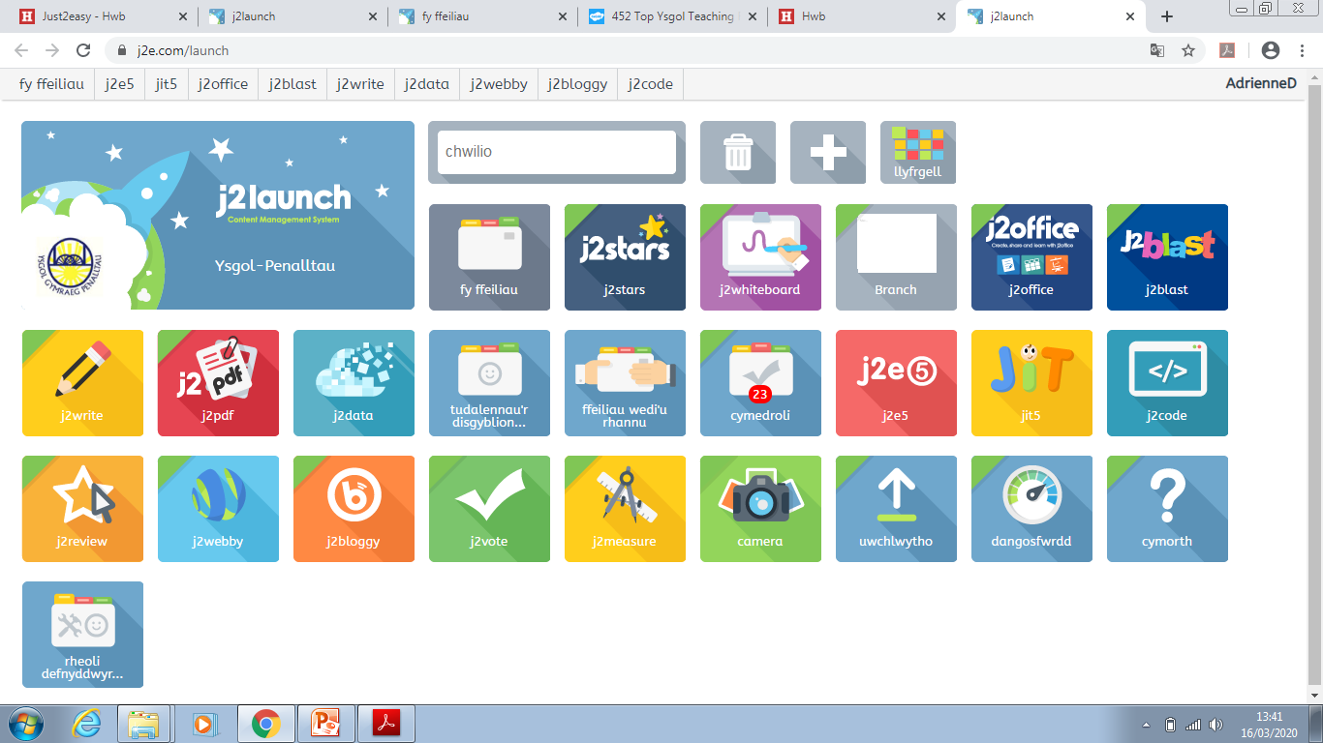

Mae jit5 yn arbennig ar gyfer plant iau yr ysgol. Mae modd iddynt ysgrifennu, creu lluniau, rhoi cyfarwyddiadau i grwban (debyg i beebot), casglu data ar siart neu bictogram ac animeiddio. Os ydych chi yn arbed eich gwaith mae modd i’r athro dosbarth eu gweld!

Jit5 is amazing for the younger children of the school. They are able to write, create pictures, give instructions to the turtle (similar to the Beebot), collect data using charts and pictograms and also animate. The class teacher is also able to see their work and give feedback!



Dyma sut rydych chi’n arbed eich gwaith.

This is how you save your work.

**Bydd angen mewngofnodi i Hwb a dewis Just2easy er mwyn cael mynediad i jit5.**

**To access jit5 you will need to log into Hwb and choose J2easy**



Mae jit5 yn arbennig ar gyfer plant iau yr ysgol. Mae modd iddynt ysgrifennu, creu lluniau, rhoi cyfarwyddiadau i grwban (debyg i beebot), casglu data ar siart neu bictogram ac animeiddio. Os ydych chi yn arbed eich gwaith mae modd i’r athro dosbarth eu gweld!

Jit5 is amazing for the younger children of the school. They are able to write, create pictures, give instructions to the turtle (similar to the Beebot), collect data using charts and pictograms and also animate. The class teacher is also able to see their work and give feedback!



Dyma sut rydych chi’n arbed eich gwaith.

This is how you save your work.