

Post Penalltau – 13/11/2025

SCROLL DOWN FOR ENGLISH VERSION

Annwyl Deuluoedd,


PAWB
ATGOF: Plant Mewn Angen
Rydym yn gyffrous i gyhoeddi y bydd ein hysgol yn cynnal Diwrnod Gwallt Gwirion Plant Mewn Angen 2024 ar ddydd Gwener, 15fed o Dachwedd! Mae’n ddiwrnod i gael hwyl, a dangos eich cefnogaeth i achos gwych. Trwy gymryd rhan, byddwn yn helpu i godi ymwybyddiaeth ac arian ar gyfer Plant Mewn Angen, elusen sy'n ymroddedig i wella bywydau plant a phobl ifanc difreintiedig ledled y DU. Bydd eich cyfranogiad yn gwneud gwahaniaeth sylweddol i fywydau'r rhai sydd ei angen fwyaf. Er mwyn cymryd rhan, gofynnir i blant i'r ysgol ar y diwrnod gyda’I wallt Gwirion! Rydym yn gofyn yn garedig am gyfraniad o £1 tuag at elusen Plant Mewn Angen ar y diwrnod yma os yw’n bosib.

*Sylwch ar y diwrnod hwn mai gwallt gwallgof yn unig fydd hi, ac i ddisgyblion ddod yn eu gwisg ysgol fel arfer.



PAWB
Perfformiad Penwythnos Goleuadau Caerffili
Oherwydd amgylchiadau annisgwyl, ni fyddwn bellach yn perfformio yn nigwyddiad goleuadau Caerffili.



PAWB
ATGOF: Tachwedd Napiau – Parish Trust
Drwy gydol mis Tachwedd, byddwn yn cefnogi menter y Parish Trust o'r enw ‘Tachwedd Napiau’. Mae’r Parish Trust yn sefydliad sy’n cefnogi teuluoedd ledled Bwrdeistref Sirol Caerffili.
Os ydych yn gallu rhoi unrhyw faint o napiau (yn enwedig maint 3 ac uwch) neu unrhyw becynnau o weips, byddwn yn eu rhoi i’r Parish Trust

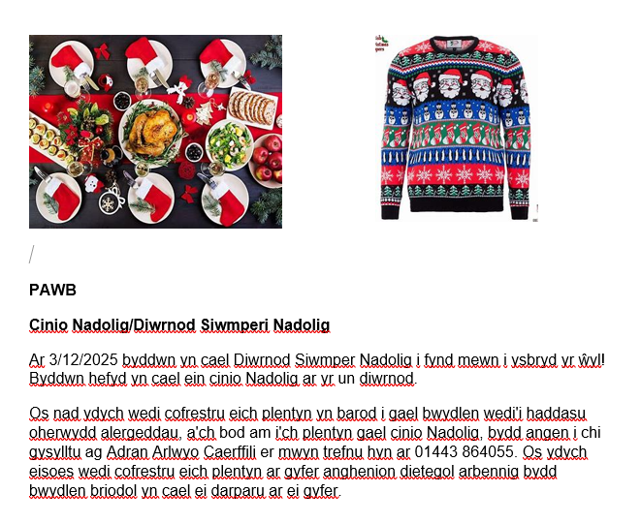
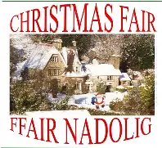

PAWB
ATGOF: Ffair Nadolig
Bydd Ffair Nadolig yr Ysgol bellach yn cael ei chynnal ar 3/12/2025 rhwng 3:30 – 4:30



PAWB
ATGOF: Dyddiadau Pwyig i’r Dyddiadur

18/11/25 – Gweithdy Darllen i Rhieni (4:30 – 5:30)
3/12/2025 – Cinio Nadolig Ysgol/Diwrnod Siwmperi Nadolig
3/12/2025 – Ffair Nadolig yr Ysgol (3:30 – 4:30)
08/12/2025 – Sioe Nadolig Blwyddyn 4/5 – (bore)
08/12/2025 – Sioe Nadolig Blwyddyn 4/5 – (prynhawn)
9/12/2025 – Sioe Nadolig Meithin/Derbyn – (bore)
10/12/2025 – Sioe Nadolig Meithin/Derbyn – (bore)
9/12/2025 – Sioe Nadolig Blwyddyn 1 – (prynhawn)
10/12/2025 – Sioe Nadolig Blwyddyn 1 – (prynhawn)
10/12/2025– Cyngerdd Carolau Blwyddyn 6 – Eglwys St Catwg, Gelligaer – 6pm – 7pm
11/12/2025 – Sioe Nadolig Blwyddyn 2/3 – (bore)
11/12/2025 – Sioe Nadolig Blwyddyn 2/3 – (prynhawn)
*Rhannir manylion am brynnu a'r dyraniadau tocynnau yn agosach at y dyddiadau
*19/12/2025 – Diwrnod Olaf Tymor
*05/01/2025 – HMS i’r staff yr ysgol
*06/01/2025 – Plant yn ddychwelyd i’r ysgol



PAWB
ATGOF: Gweithdy Darllen i Rhieni
Ar ddydd Mawrth, 18fed o Dachwedd, rhwn 4:30 – 5:30pm byddwn yn cynnig gweithdy i rieni yn canolbwyntio ar ddarpariaeth a datblygiad darllen. Bydd y sesiwn yn archwilio sut mae darllen yn cael ei gefnogi yn yr ysgol ac yn cynnig syniadau i helpu disgyblion gartref.

PAWB
ATGOF: Her y Mis – Arweinwyr Digidol

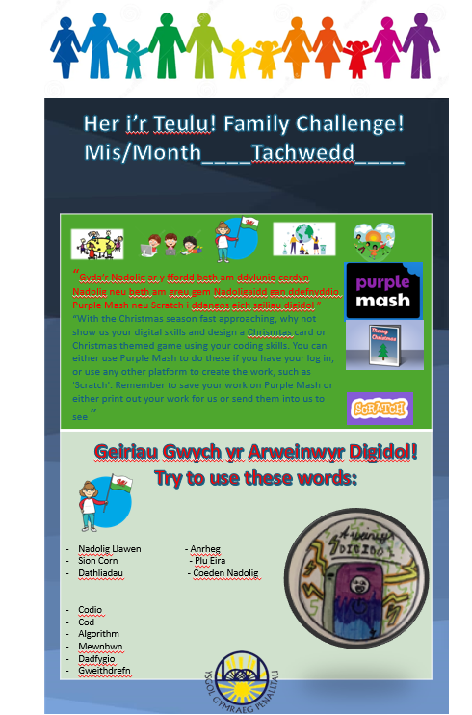


EVERYONE
REMINDER: Children in Need
We are excited to announce that our school will be holding a Wild Hair Day in support of Children in Need 2024 on Friday, 15th of November! This will be a day to have fun, and show your support for a great cause. By participating, we will be helping to raise awareness and funds for Children in Need, a charity dedicated to improving the lives of disadvantaged children and young people across the UK. Your involvement will make a significant difference in the lives of those who need it most. To get involved, children are asked to simply to style their hair in a whacky way on the day! We ask kindly for a pound £1 donation for each family for the Children in Need Charity

*Please note on this day it will be wacky hair only, and for pupils to come in their school uniform as normal.

EVERYONE
Caerphilly Lights Weekend Performance
Due to unforeseen circumstances, we will now not be performing at the Caerphilly lights event.

EVERYONE
REMINDER: Nappy November – The Parish Trust
Throughout November we will be supporting the Parish Trust initiative ‘Nappy November’. The Parish Trust are an organisation who support families throughout Caerphilly County Borough. If you are able to donate any size nappies (especially size 3 and bigger) or any packets of wipes we will donate them to the Parish Trust.



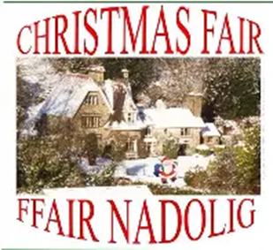

EVERYONE
REMINDER: Christmas Fair

The School Christmas Fair will now be held on 3/12/2025 from 3:30 - 4:30

EVERYONE
REMINDER: Important Dates for the Diary

18/11/2025 – Reading Workshop for Parents
3/12/2025 – School Christmas Dinner/Christmas Jumper Day
3/12/2025 – School Christmas Fair (3:30 – 4:30)
08/12/2025 – Christmas Performance Year 4/5 – (morning)
08/12/2025 – Christmas Performance Year 4/5 – (afternoon)
9/12/2025 – Christmas Performance – Nursery/Reception – (morning)
10/12/2025 – Christmas Performance – Nursery/Reception – (morning)
9/12/2025 – Christmas Performance Year 1– (afternoon)
10/12/2025 – Christmas Performance Year 1 – (afternoon)
10/12/2025 – Carol Service - Year 6 – St Catwgs Church, Gelligaer – 6pm – 7pm
11/12/2025 – Christmas Performance Year 2/3 – (morning)
11/12/2025 – Christmas Performance Year 2/3 – (afternoon)

*Details of ticket purchases and allocations will be shared closer to the dates

*19/12/2024 – Last Day of Term
*05/01/2025 – School INSET day
*06/01/2025 – Children return to school

EVERYONE
REMINDER: Reading Workshop
On Tuesday, 18th November between 4:30pm – 5:30pm we will be offering a workshop for parents focused on reading provision and development. The session will explore how reading is supported in school and offer ideas to help pupils at home.

EVERYONE
REMINDER: Monthly Challenge – Digital Leaders

Cysylltiadau pwysig a all fod o ddefnydd i chi / Important contact details that could be of use to you:

Caerphilly Employment Support: 01443 864227
Samaritans: 116 123 (24 awr y dydd / 24 hours a day)
Wales Domestic Abuse Helpline: 0808 80 10 800 (8.00am-2.00pm & 8.00pm-2.00am pob dydd / every day).
Mind Cymru: 0300 123 3393
Warm Wales: 01656747622/ information@warmwales.org.uk
Childline: 0800 1111 (24 awr y dydd / 24 hours a day)
Women’s Aid: 01495 742061 (24 awr y dydd / 24 hours a day)
Eastern Valley Food Bank: 01495 760605
National Energy Action Cymru: 08003047159
The Rainy Day Trust: 08009154627/ info@rainydaytrust.org.uk
Fuel Poverty Action: contact@fuelpovertyaction.org.uk
Care & Repair Cymru, 70+ Cymru: careandrepair.org.uk/get-help/
Caerphilly Cares: caerphillycares@caerphilly.gov.uk
Eco Funding: 01443 811378



