Dear Parent / Carer,
Here is an overview of the work your child will be covering during this term.
Languages Literacy and Communication
Through our language and thematic sessions, pupils will develop their ability to choose language for effect in English and Welsh, both in oral and written work: looking in detail at choices of sentence openers, use of complex punctuation, extensive vocabulary (including subject specific) and connectives. A wide range of reading opportunities will help develop reading skills such as expression, skimming, scanning and summarising and higher order skills such as inference. Pupils will be supported to become more confident in using a dictionary, thesaurus and glossary. We will be continuing to practise handwriting to ensure the best presentation and legibility possible. Your child will become increasingly aware of the connection between languages with a specific focus on learning to speak, read and write in French.
Mathematics and Numeracy
Number skills are our main driver and these skills are practised regularly through authentic learning experiences such as measuring, using data, money, algebra and geometry. Even at the top of the school we use many manipulatives [hands on resources] and pictorial methods to help deepen the children’s understanding to re-enforce written methods. It is not just about getting the right answer - We encourage children to talk about their work, explain what they know or what helped and to use different methods to check their workings. For further information, please see the numeracy framework on our school website.

Theme Work
Our theme this season is ‘Ein Byd Rhyfeddol’ or 'Our Amazing World.' The class will look at the impact of human actions on the natural world and simply discuss and explain how and why certain places, spaces, environments and landscapes are particularly important to different people. There will be an opportunity to consider the characteristics of living things and begin to use suitable vocabulary: Movement, Cultivation, Sensitiveness, nutrition, reproduction. Children will also retrieve information about the distribution of living things and explain that living things are distributed to five kingdoms. Ernst Haekel's illustrative work will inform our art looking at colour, shade and tone in painting. We will learn digital media skills to create a presentation on the work of the term. The class will get to know about Ethical Veganism and its values.

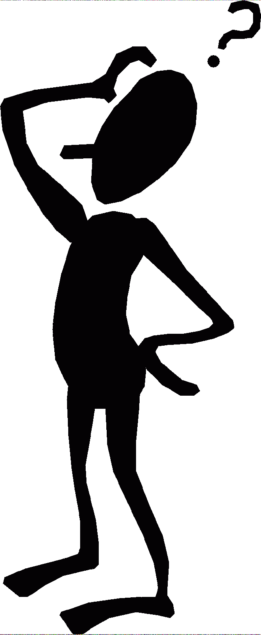
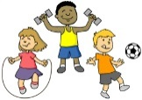
Health and Wellbeing:-
During exercise sessions, a focus on athletics will lead up to the Mabolgampau. This season's Jigsaw themes are: Relationships and Change.

Class: Gelert

Year: 4/5

Things to Remember
Books to read home Friday and back EVERY Monday with a record.
Exercise kit on Monday.
Woodland clothes will be required every other Wednesday (starts 22/4)
Use Instagram to share work or successes or email the school!

