YSGOL PENALLTAU

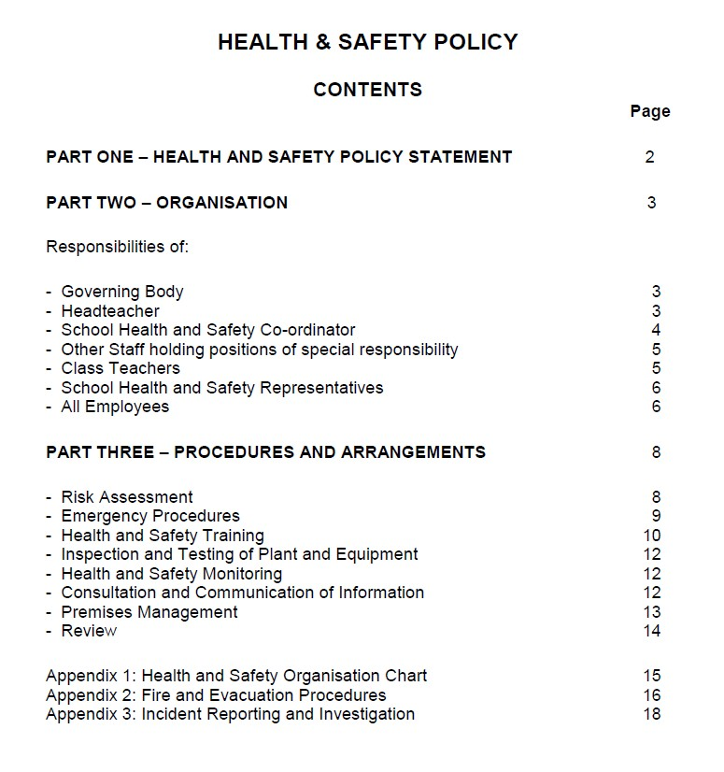

HEALTH AND SAFETY POLICY

PART ONE

POLICY STATEMENT

Ysgol Penalltau

The Governing Body believes that ensuring the health and safety of staff, pupils and visitors is essential to the success of the school.

We are committed to:
- Providing a safe and healthy working and learning environment
- Preventing accidents and work-related ill health
- Assessing and controlling risks from curriculum and non-curriculum work activities
- Complying with statutory requirements as a minimum
- Ensuring safe working methods and providing safe equipment
- Providing effective information, instruction and training
- Monitoring and reviewing systems to make sure they are effective
- Developing and maintaining a positive health and safety culture through communication and consultation with employees and their representatives on health and safety matters
- Setting targets and objectives to develop a culture of continuous improvement
- Ensuring adequate welfare facilities exist at the school
- Ensuring adequate resources are made available for health and safety issues, so far as is reasonably practicable

A Health and Safety Management System has been created to ensure the above commitments can be met. All Governors, staff and pupils will play their part in its implementation.

HEALTH AND SAFETY POLICY

PART TWO

ORGANISATION

INTRODUCTION

To comply with the Governing Body’s Policy Statement the school’s normal management structure have had additional responsibilities assigned, as detailed below.

An organisational chart showing the school’s health and safety management structure is attached at Appendix 1.

THE GOVERNING BODY

The Governing Body has the following responsibilities to ensure:

- A clear written policy statement is created which promotes the correct attitude towards safety in staff and pupils.

- Responsibilities for health, safety and welfare are allocated to specific people and those persons are informed of these responsibilities.

- Persons have sufficient experience, knowledge and training to perform the tasks required of them.

- Clear procedures are created which assess the risk from hazards and produce safe systems of work.

- Sufficient funds are set aside with which to operate safe systems of work.

- Health and safety performance is measured both actively and reactively.

- The school’s health and safety policy and performance is reviewed annually.

THE HEADTEACHER

The Headteacher has the following responsibilities:

- To be fully committed to the Governing Body’s Policy Statement for Health and Safety.

- Ensure that a clear written local Policy for Health and Safety is created.

- Ensure that the Policy is communicated adequately to all relevant persons.
- Ensure appropriate information on significant risk activities is given to visitors
and contractors.

- Ensure appropriate consultation arrangements are in place for staff and their Trades Union representatives.

- Ensure that all staff are provided with adequate information, instruction and training on health and safety issues.

- Make or arrange for risk assessments of the premises and working practices to be undertaken.

- Ensure safe systems of work are in place as identified from risk assessments.

- Ensure that emergency procedures are in place.

- Ensure that equipment is inspected and tested to ensure it remains in a safe condition.

- Ensure records are kept of all relevant health and safety activities e.g.
assessments, inspections, accidents, etc.

- Ensure arrangements are in place to monitor premises and performance.

- Ensure that all accidents are investigated and any remedial actions required are taken or requested.

- Report to the Governing Body annually on the health and safety performance of the school.

SCHOOL HEALTH AND SAFETY CO-ORDINATOR

The School Health and Safety Co-ordinator (the Head teacher) has the following responsibilities:

- To co-ordinate and manage the annual risk assessment process for the school.

- To co-ordinate the annual general workplace monitoring inspections and performance monitoring process.

- To make provision for the inspection and maintenance of work equipment throughout the school.

- To manage the keeping of records of all health and safety activities including management of building fabric and building services.

- To advise the Headteacher of situations or activities which are potentially hazardous to the health and safety of staff, pupils and visitors.

f)To ensure that staff are adequately instructed in safety and welfare matters about
their specific work place and the school generally.
g) Carrying out any other functions devolved to her/him by the Headteacher or Governing Body.

TEACHING/NON-TEACHING STAFF HOLDING POSITIONS OF SPECIAL RESPONSIBILITY

This includes Deputy Headteachers, Leaders of Teaching and Learning, Admin Manager and Caretaker. They have the following responsibilities:

- Apply the school’s Health and Safety Policy or relevant County Council Health and Safety Code of Practice to their own department or area of work and be directly responsible to the Headteacher for the application of the health and safety procedures and arrangements.

- Carry out regular health and safety risk assessments of the activities for which they are responsible.

- Ensure that all staff under their control are familiar with the health and safety Code of Practice, if issued, for their area of work.

- Resolve health, safety and welfare problems which members of staff refer to them, or refer to the Headteacher any problems to which they cannot achieve a satisfactory solution within the resources available to them.

- Carry out regular inspections of their areas of responsibility to ensure that equipment, furniture and activities are safe and record these inspections where required.

- Ensure, so far as is reasonably practicable, the provision of sufficient information, instruction, training and supervision to enable other employees and pupils to avoid hazards and contribute positively to their own health and safety.

- Investigate any accidents that occur within their area of responsibility.

- Prepare an annual report for the Headteacher on the health and safety performance of her/his department or area of responsibility.

CLASS TEACHERS

Class teachers are expected to:

- Exercise effective supervision of their pupils, to know the procedures for fire, first aid and other emergencies and to carry them out.

- Follow the particular health and safety measures to be adopted in their own teaching areas as laid down in the relevant Policy, and to ensure that they are applied.

- Give clear oral and written instructions and warnings to pupils when
necessary.

- Follow safe working procedures.

- Require the use of protective clothing and guards where necessary.

- Make recommendations to their Headteacher or Head of Key Stage on health and safety equipment and on additions or necessary improvements to plant, tools, equipment or machinery.

- Integrate all relevant aspects of safety into the teaching process and, where necessary, give special lessons on health and safety in line with National Curriculum requirements for safety education.

- Avoid introducing personal items of equipment (electrical or mechanical) into the school without prior authorisation.

- Report all accidents, defects and dangerous occurrences to their Head of Key Stage.

SCHOOL HEALTH AND SAFETY REPRESENTATIVES

The Governing Body recognises the role of Health and Safety Representatives appointed by a recognised trade union. Health and Safety Representatives will be allowed to investigate accidents and potential hazards, pursue employee complaints and carry out school inspections within directed time but, wherever practicable, outside teaching time. They will also be consulted on health and safety matters affecting all staff.

They are also entitled to certain information, e.g. about accidents and to paid time off to train for and carry out their health and safety functions. However, they are not part of the management structure and do not carry out duties on behalf of the Headteacher or Governing Body.

ALL EMPLOYEES

All employees have individual legal responsibilities to take reasonable care for the health and safety of themselves and for others who may be affected by their acts or omissions. In particular, employees must:

- Always comply with the school’s health and safety policy and procedures – in particular procedures for fire, first aid and other emergencies.
- Co-operate with school management in complying with relevant health and safety law.
- Use all work equipment and substances in accordance with instruction, training and information received.
- Report to their immediate line manager any hazardous situations and defects in equipment found in their workplaces.
- Report all incidents in line with current incident reporting procedure.
- Act in accordance with any specific health and safety training received.
- Inform their Line Manager of what they consider to be shortcomings in the school’s health and safety arrangements.
- Exercise good standards of housekeeping and cleanliness.
- Co-operate with appointed Trade Union Health and Safety Representative(s).

PUPILS

Pupils, allowing for their age and aptitude, are expected to:

- Exercise personal responsibility for the health and safety of themselves and others.

- Observe standards of dress consistent with safety and/or hygiene.

- Observe all the health and safety rules of the school and in particular the instructions of staff given in an emergency.

- Use and not wilfully misuse, neglect or interfere with things provided for their health and safety.
HEALTH AND SAFETY POLICY

PART THREE

PROCEDURES AND ARRANGEMENTS

INTRODUCTION

The following procedures and arrangements have been adopted to ensure compliance with the Governing Body’s Statement of Intent.

RISK ASSESSMENT

General Risk Assessment

General Risk Assessment will be co-ordinated by the Headteacher following the guidance issued by CCBC.

Maternity Risk Assessment

Maternity Risk Assessments will be carried out by CCBC Health & Safety.

Curriculum Activities

Risk Assessments for Curriculum activities will be carried out by relevant Heads of Key Stage using guidelines issued by the County Council.

Fire

A fire risk assessment will be carried out by CCBC Health and Safety

Manual Handling

Manual handling risk assessments will be carried out by the CCBC Health and Safety

Computers and Workstations

Computer and workstation risk assessments will be carried out by CCBC Health and Safety following guidelines outlined in Display Screen Equipment Regulations 1992.

Hazardous Substances

The Caretaker will identify hazardous substances and a risk assessment will be undertaken by the Head teacher following advice from CCBC Health and Safety.

Violence
Assessment of the risks of violence to staff will be carried out by CCBC Health and Safety.

EMERGENCY PROCEDURES

Fire and Evacuation

Fire and evacuation procedures are detailed in Appendix 2.

First Aid

First aid boxes are provided at the following locations:

Every classroom and main Office

The following staff are available to provide first aid:

Certificated (First Aid at Work qualified) First Aiders:
Ashley Gittings
Zoey Dolloway

Certificated (Emergency First Aid at Work qualified) First Aiders:

Louise Monaco
Lowri Owen
Tom Rainsbury
Leah Rees
Jessica Iles
Sarah Vokes
Leah Rees
Rebecca Poole
Sarah Higgs
Niamh Jenkins
Elinor Bushell
Hannah Packard
Menna Parry
Amy Poole

Certificated Paediatric First Aiders (required for children up to age 5):
Victoria O’Leary Knapper
Karen Browning
Megan Williams
Emma Edwards
Cerys Broad

In event of needing first aid assistance, either: -

Locate the nearest first aider or phone office who will locate the nearest first aider and cover their class if required.

Transport to hospital:

If an ambulance is required, call “999”. It may be appropriate in less severe cases to transport a pupil to a casualty department without using an ambulance, but this should always be on a voluntary basis. If a member of staff uses their own car for these purposes, they must ensure that they have obtained specific cover from their insurance company. The school will reimburse additional insurance premiums where necessary.

No casualty should be allowed to travel to hospital unaccompanied. The Head teacher will designate an accompanying adult in emergencies where parents
cannot be contacted.

Incident Reporting

See Appendix 3.

Gas Leaks

Any member of staff discovering a suspected gas leak should make an informed judgement based on how strong the smell is as to whether they immediately evacuate the building and telephone the Gas Emergency Service on 0800 111 999.

If there is a slight smell of gas, the first action should be to check that all gas appliances are switched off. This may clear the smell of gas. Windows should be opened.

Electrical Fires

Any member of staff discovering a suspected electrical fire should immediately trigger the evacuation process and telephone the Fire Service by dialling ‘999’.

HEALTH AND SAFETY TRAINING

Health and safety induction training will be arranged for all new employees by the Head teacher.

The following staff have received health and safety training in the following areas:

- Health and Safety Awareness

All staff in post via Staff Handbook

- Premises Management

……Headteacher……………………………………………………

- ………………………………………………………….

- Premises Management – Fire Safety

……All Staff……………………………………………………

Outdoor Education:

- Educational Visits Co-ordinator

Lowri Owen
………………………………………………………

Occupational Risks

- General Risk Assessment

The Head teacher

Caretaking

- School Caretakers - Health and Safety Awareness
Safe use of ladders

- Caretakers Workshop
- CCBC Health and Safety (Induction)
- Fire Awareness and Warden Training
- Managing lone working Safely
- Legionella Training
- Playground Equipment Checks and Maintance Training

- Water temperature checks (legionella)

The Caretaker

Training records are held by the Headteacher.

The Head teacher, in conjunction with the INSET Co-ordinator, will identify training needs.

INSPECTION AND TESTING OF PLANT AND EQUIPMENT

Statutory Inspections

All plant and equipment requiring statutory inspection and testing will be inspected by appropriate contractors through the Building Maintenance SLA. Evidence can be found on the Risk Assessment Management Information System (RAMIS).

Portable Electrical Appliances

Inspection and testing of portable electrical appliances will be carried out following guidance contained in the Building Maintenance SLA. Evidence can be found on the Risk Assessment Management Information System (RAMIS).

Equipment Maintenance - Curriculum

Heads of Key Stages will be responsible for ensuring that maintenance of equipment for their areas of the curriculum is identified and implemented following guidance contained in health and safety documentation.

HEALTH AND SAFETY MONITORING

Inspection of Premises

General Workplace Inspections will be co-ordinated by the Head teacher. A log is kept in the Building Maintenance File and relevant information imputed into the Risk Assessment Management Information System (RAMIS).

CONSULTATION AND COMMUNICATION OF INFORMATION

Consultation

The premises Health and Safety Committee (Governing Body) meets termly to discuss health, safety and welfare issues affecting staff, pupils or visitors. Action points from meetings are brought forward for review by school management.

The Trade Unions’ appointed Safety Representative(s) on the staff is/are: ……………………………

Communication of Information

The premises manager will ensure that systems are established so that staff and pupils are familiar with the arrangements set out in this document.

The Health and Safety Law poster is displayed in the staffroom

Health and safety advice is available from CCBC Health and Safety.

PREMISES MANAGEMENT

Supervision of Pupils

Arrangements for supervision of pupils are as noted in the Staff Handbook:

Security and Visitors

All visitors must report to the School Office where they will be asked to sign in on the digital system

Vehicles on Site/Parking

Cars must be parked in designated areas.

The risks of persons and vehicles coming into contact will be controlled by the Head teacher and Caretaker.

Delivery/contractor vehicles must park at the main gate to arrange supervised access.

Building Maintenance

General building maintenance is carried out by DLO Rapid Repairs or designated contractors.

Asbestos

No Asbestos in building (Building built in 2009)

Control of Contractors

All contractors must report to the school office where they will be asked to sign the digital sign in system. Contractors will be issued with guidance on fire procedures, local management arrangements and vehicle movement restrictions.

The Caretaker is responsible for monitoring areas where the contractor’s work may directly affect staff and pupils and for keeping records of all contractor work.

.

OTHER PROCEDURES

Critical Incident Management

CCBC’s Critical Incident Management guidelines are followed and staff are made aware of the advice given.

Managing Medicines

CCBC’s guidelines will be followed at all times..

Educational Visits

Educational visits will be organised following guidance by CCBC and DfES. The Educational Visits Co-ordinator is the Head teacher.

REVIEW
These arrangements will be reviewed annually and revised as new topics arise which may affect the process of managing health and safety for staff, pupils, contractors and other visitors.

Adopted by the Governing Body:

Chair of Governing Body ____Aled Hopkin_______________________

Signed Head teacher ____Tom Rainsbury_______________________

Review Date: 09:2026

Appendix 1

Ysgol Penalltau

HEALTH AND SAFETY ORGANISATIONAL CHART



Governing Body

LEA

Headteacher

School Management

Team

Heads of Key

Stages

Caretakers

Teachers

Contractors

Support Staff

School H&S Co

-

ordinator

Ad

min Staff

Appendix 2

FIRE AND EVACUATION PROCEDURES

- Fire notices are displayed at every exit point.

- Escape routes are checked by the Caretaker weekly

- Fire Extinguishers are maintained and checked by an external contractor annually

- Alarms (call points) are tested by the Caretaker on a weekly cycle

Emergency evacuation procedure will be tested once every term.

PREMISES EVACUATION ARRANGEMENTS in case of an alarm being activated are as follows: -

Staff discovering a fire or other emergency for which the buildings should be evacuated should activate the alarm by breaking the glass on the nearest call point. They should then notify the main office of the exact location.

The EMERGENCY WARNING is the ALARM SIREN ringing continuously.

The Head teacher (or Deputy in her/his absence) will go to the zone where the alarm has been set off to investigate if there is a fire or false alarm. He/she will dial 999 if it is a fire.

On hearing the alarm, pupils should leave in single file when instructed by the teacher in charge of the class. Pupils should then leave by the nearest available marked escape route. The last person to leave the classroom must close the door. Pupils should walk in their subject groups and remain with their teacher at the assembly point.

If a pupil is not in a classroom when the alarm sounds, he/she must walk to the assembly point leaving the building by the nearest marked escape route.

In the event of an emergency during BREAK or the LUNCH HOUR, pupils must leave the building by the nearest marked escape route and go to the assembly area for the site they are on at the time of the emergency. Pupils should assemble in registration groups.

Staff not with pupils, visitors and contractors must leave the building by the nearest exit and report directly to the senior office staff at the assembly point.

Disabled pupils’ timetables will be held in the main offices for access in an emergency. The Health and Safety Co-ordinator will discuss with any disabled pupils and their parents the evacuation procedure in case of an emergency and draw up a Personal Emergency Evacuation Plan (PEEP) following guidance by CCBC Health and Safety.

• The assembly areas are:

- Tarmac area on the rear (School Yard) and front (car park) side of the building

- A senior member of staff (deputy or head of SLT) will undertake supervision of the assembly areas.

Immediately pupils arrive at the assembly area, they must stand in their groups in silence while staff make a head count and then check their registers. The result of this check must be reported to the person in charge as soon as it is completed.

- The Head teacher (deputy) will collect a radio from the office and sweep the building once the fire brigade has been informed.

The deputy (head of key stage) will liaise to check that any named disabled pupils and helper or disabled visitors have been evacuated.

Routes for building sweep are displayed in each room.

The Head teacher will liaise with the Fire Brigade on their arrival.

In the event of a false alarm the Head teacher will direct staff, pupils and visitors to return to the building.

Appendix 3
OTHER EMERGENCIES

The Keyperson for contacting parents will be the Headteacher or in her/his absence the Acting Headteacher.

INCIDENT REPORTING AND INVESTIGATION

All incidents will be reported in accordance with guidance contained in the Building Manager’s File.
To comply with the Data Protection requirements, individual incident reports will be removed from the Incident Book, passed to the Headteacher and stored securely to ensure that personal details remain confidential.
Minor accidents to pupils and visitors will be reported on the appropriate Accident Form. These forms are held at the school office.

Investigation of Incidents and Remedial Action

The Headteacher will investigate all incidents and make appropriate recommendations to prevent a recurrence.

Reporting

The person responsible for recording and reporting of incidents to CCBC and maintaining records is the Headteacher

Adopted by the Governing Body: 09/25

Signed (Chair of Governors) ___________________________

Signed (Head Teacher) ___________________________

Review Date : 09/2026

