
Homework Menu
Year 2
Dwynwen
Summer Term
Thema: Our Wonderful World
Mwynhewch!

Mains
Choose 4 to complete during the term.

Go on an insect hunt! Use a tally chart to keep track of all the animals that you see!
What effects do humans have on different habitats? How can we reduce the damage that we cause?
Discover information about one habitat that animals live in and create a poster or video about the habitat.
Research to see which animals lay eggs and which animals do not. Can you show your findings in a creative way?
We are learning about the importance of recycling and reducing pollution. What about going to your local area and partaking in a clean-up? Can you sort your rubbish into the correct categories?
Make an animation of a simple life cycle / food chain.
Visit two different habitats e.g. the beach and the forest. Can you make a Venn Diagram to show the similarities and differences between the habitats?

Dessert
Optional during the term.
Grow your own plant! Can you keep a diary to track the growth of the plant?

Collect facts about the artist Henri Rousseau. Can you create a piece of artwork inspired by his work?

Starters
To be completed consistently during the term.
Practice your 2, 5 and 10 times tables.
Practice your spelling each week (words have been sent home).
Go to the library and read a factual book about animals.
Practice forming numbers 1-100 correctly.
Practice your handwriting remembering to form each letter correctly (especially ‘b’ and ‘d’).
Complete the dragon’s challenges.

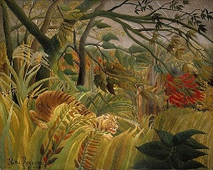




Tymor yr Haf
Thema: Ein Byd Rhyfeddol
Mwynhewch!
Bwydlen Gwaith Cartref
Blwyddyn 2
Dosbarth Dwynwen
Prif Gwrs
Dewiswch 4 i’w cwblhau dros y tymor.

Ewch ar helfa trychfilod! Defnyddiwch siart ricbren i gadw cofnod o’r holl anifeiliaid rydych chi’n gweld!
Pa effaith ydy pobl yn cael ar gynefinoedd gwahanol? Sut allwn ni lleihau’r niwed rydym ni’n gwneud?
Darganfyddwch wybodaeth am un cynefin y mae anifeiliaid yn byw ynddo a chreu poster gwybodaeth neu fideo am y cynefin.
Ymchwiliwch i weld pa anifeiliaid sydd yn dodwy wyau a pha anifeiliaid sydd ddim. Allwch chi arddangos eich canfyddiadau mewn ffordd creadigol?
Wrth i ni ddysgu am bwysigrwydd ailgylchu a lleihau llygredd, beth am fynd am sesiwn codi sbwriel yn eich ardal leol? Allwch chi ddidoli eich sbwriel yn y categorïau cywir?
Gwnewch animeiddiad o gylchred bywyd / cadwyn fwyd syml.
Ymwelwch â ddau gynefin wahanol e.e y traeth a’r goedwig. Ydych chi’n gallu gwneud Diagram Venn i arddangos y nodweddion tebyg a gwahanol?

Cofiwch eich bod yn gallu trydar llun o’ch gwaith i @penalltau

Pwdin
Dewisol yn ystod y tymor:
Tyfu planhigyn eich hunain! Ydych chi’n gallu cadw dyddiadaur i dracio tyfiant y planhigyn?

Casglwch ffeithiau am yr arlunydd Henri Rousseau. Ydych chi’n gallu gwneud darn o gelf sydd wedi ysbrydoli gan ei waith?
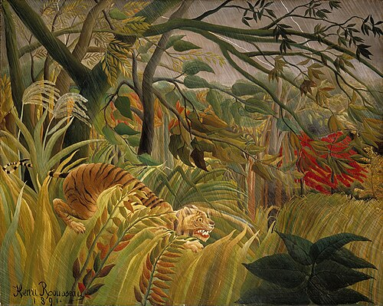

Cwrs Cyntaf
Gwnewch bob un yn gyson dros y tymor.
Ymarfer tablau 2, 5 a 10.
Ymarfer eich sillafu pob wythnos (geirfa wedi mynd adref).
Mynd i’r llyfrgell a darllen llyfr ffeithiol am anifeiliaid.
Ymarfer ffurfio rhifau 1- 100 yn gywir.
Ymarfer eich llawysgrifen gan gofio i ffurfio bob llythyren yn gywir (yn enwedig ‘b’ a ‘d’).
Cwblhau heriau’r dreigiau.

