To be presented on the school’s website. Other formats available through school office on request.

The Governing Body
The Governing Body is responsible for the effective management of the school. Terms of office are normally four years, and the Full Governing Body is currently constituted as shown below.
Name | Governor Type | Term of Office
Ms K Grindal | (Chairperson) L.A. representative
Mr T Williams | (Vice) Community representative | Terminated 13/1/23
VACANCY | Community representative
Mrs J Jones | L.A. representative | Terminated 27/11/22
Ms R Spiller | L.A. representative
Mrs B Jones | L.A. representative | Terminated 17/10/22
Mrs H Ault | L.A. representative
Mrs S Boyles | Community Representative | 22/03/2027
Mrs V Beck | Community representative | 28/01/2024
Ms L Williams | Minor Authority | Terminated 6/9/22
Cllr C Moss | Minor Authority | 13/10/2026
Mrs G Harris | Parent Representative | 27/04/2026
Mr I Urquhart | Parent Representative | 06/06/2025
Mr A Hopkin | Parent Representative | 27/02/2026
Mrs H Marsh | Parent Representative | Terminated 11/7/23
VACANCY | Parent Representative
Mrs Lowri Owen | Teaching Representative | 12/10/2023
Mrs Andrea Woods | Head teacher | (ex officio)
Miss Jayne Richards | Staff Representative | 05/11/2024

The clerk to Governors is Mrs Anna Lewis, who may be contacted via the
EAS Governor Support: Governor Support Team
Tel: 01443 863221 Governor.support@sewaleseas.org.uk

A REVIEW OF GOVERNOR'S ACTIVITY FOR THE ACADEMIC YEAR 2022/23
Ms K Grindal was reappointed as Chair. Throughout the year we have seen several changes to membership. We were extremely sorry to see Mrs J Jones and Mr T Williams leave the governing body-both of which have been members of our governing body for over 13 years. Mrs Jones was one of the founder members of our governing body, (appointed even before the school was officially open!) and was instrumental in establishing Ysgol Penalltau. Mr Williams joined us shortly after in 2010. We are very grateful to them for the huge dedication and support they have shown over the years-they will certainly be missed. We would also like to thank Mrs B Jones, Miss L Williams and Mrs H Marsh for their commitment and support during their term of office.
In this academic year, we have welcomed Cllr C Moss (Minor authority) and Miss R Spiller and Mrs H Ault (Local Authority). We look forward to working together. We will shortly be requesting nominations for the vacancy of Parent Representative.
Over the academic year, Governors were again heavily involved in the management of the school and have met regularly both face to face and virtually. The Governing Body have agreed on the distribution of responsibilities for areas such as finance, safeguarding, buildings, recruitment, and staffing, along with statutory committees, to our sub-committees. Link governors were elected as follows:
a. Child Protection / Safeguarding - Mr T Williams/ Mrs G Harris
b. Looked After Children (LAC) - Mr T Williams/ Mrs G Harris
c. Additional Learning Needs (ALN) - Mr T Williams/ Mrs L Owen
d. Closing the Gap Governor (PDG/FSM) - Mrs S Boyles/ Mrs G Harris
e. More Able and Talented (MAT) – Ms K Grindal/ Mrs H Marsh
f. Training Governor (Link Governor for Training and Development) – Ms K Grindal
g. Self-Evaluation Champion – Ms K Grindal
h. Hwb Champion – L Owen
i. Health and Safety - Mrs S Boyles/ Mr A Hopkin
j. Language Charter – I Urquhart/ V Beck
k Distance Learning – L Owen/ I Urquhart
l. Attendance – Cllr C Moss
Governors have supported several school events such as concerts, assemblies and Sports Day. It has been a pleasure to see such confident and enthusiastic pupils.
Members of the School Council delivered a presentation to governors outlining what the curriculum means to pupils at our school. Pupils certainly demonstrated the core purposes of the curriculum and have obviously engaged enthusiastically in curriculum design and evaluation. The pupils spoke from the heart and outlined the activities they undertook to gain real life experiences and explained that all the pupils have experiences that are suitable for their age. Respect, representing the school, Welshness, feeling like a family and being one team as a school were noted as things that are important to pupils. Pupils outlined how they care for others as well as creating an eco-culture within the school.
The governors met with our Education Welfare Officer to review our policy and procedures for improving attendance. The governors also received input from our School Council.
The headteacher provides the Governors with termly updates on the school’s progress towards School Development Plan Targets and pupil progress.
In terms of finance, the committee continued to work tirelessly with the head to ensure that we gain best value for money. The school is managing its budget effectively during these challenging times of cutbacks and restrictions. Grant funding has been used effectively to support learners and ensure professional development of all staff. A Finance sub-committee meeting was held to discuss end of year figures and to set our budget and grant spending plan for 2023-24.

Budget Report 2022-23
School Budget - Expenditure and Income (April 2022– March 2023) Area of Spending | Total Amount
Staffing Costs | £867,050
Premises Related Costs | £95,080
Supplies and Services | £63,288
School Development Plan | £33,164
LA Service Level Agreements | £26,261
Total Expenditure | £1,084,843
Income | £194,025
Net Expenditure | £890,818
Funding | Amount
Total Formula Allocation | £841,275
Balance carried forward from previous year | £204,364
Total Funding | £1,045,639
Overall Balance | £154,821(Carried forward)
Governors have agreed to staff changes and class structures which are reflected in the school prospectus. New members of staff were appointed to cover members of staff who are to begin maternity leave and fixed-term positions.
No parent meeting was held under Section 94 of the School Standards Organisation (Wales) Act 2013 in 2021-22.
If parents wish to use their rights under the Act to hold a meeting, four conditions will need to be satisfied:
- Parents will need to raise a petition in support of holding a meeting.
- The meeting must be called to discuss matters which affect the school.
- A maximum of three meetings can be held during the school year.
- There must be at least 25 school days left in the school year.
Further advice on how parents may go about requesting a meeting with the governing body is available on the Welsh Government’s website at https://beta.gov.wales/sites/default/files/publications/2018-03/statutory-guidance-to-the-governing-bodies-of-maintained-schools-in-wales-regarding-the-duty-to-hold-meetings-with-parents.pdf

Complaints
There have been no formal complaints brought to Governors.
Attendance

Attendance - All statutory school age pupils
Autumn 2022 | Attendance: 92.25%  Authorised absences: 6.97%  Unauthorised absences: 0.78%
Spring 2023 | Attendance: 93.57%  Authorised absences: 5.24%  Unauthorised absences: 1.19%
Summer 2023 | Attendance:92.19%  Authorised absences:5.81%  Unauthorised absences:2%
Whole Year 2022-23 | Attendance:92.6%  Authorised absences:6.1%  Unauthorised absences: 1.3%

During 2022-23, 705 days of schooling were missed by pupils due to holidays. Parents are reminded that holidays (even when authorised) are absences and therefore discouraged. Only 5 days of holidays will be authorised each academic year (except in exceptional circumstances) Holidays for pupils with historically low attendance will not be authorised. If you have no alternative but to take holidays during school term, please try to use INSET days/ school holidays at the beginning or end of your holiday period to limit absences.

As a nation we are all battling to get attendance levels back to pre-pandemic levels. Our attendance for statutory-aged pupils is currently 2.4% lower than the pre-pandemic academic year 2018-19.
As a school we continue to promote good attendance and engagement in learning and are proactive in addressing persistent absenteeism. However, holidays are still having a major impact on attendance.

Most pupils and parents think 90% attendance is good. Are they right?
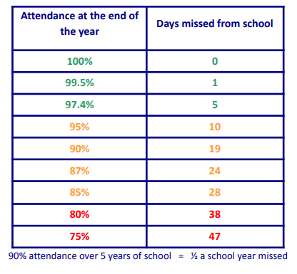

90% attendance = ½ a day missed every week!

The Welsh Government have set a primary Attendance Target of 95%

Our attendance strategies have successfully reduced persistent absenteeism (under 80%) from 15.9% in September by 4.4% in May.

In 2021-22 eFSM attendance was 5.14% lower than non-eFSM. We are slowly closing this gap. Attendance of eFSM pupils is currently 4.54% lower than non-eFSM pupils.

Exclusions

No fixed term exclusions have been given during this academic year.

School Times
 | Morning | Afternoon
Nursery | 09.00 – 11.45 am sessions only | Optional ‘Cylch’ session - 12.45-3.15
Reception-Y2 | 09.00-12.00 | 1.00-3.15
Y3-6 | 09.00-12.15 | 1.00-3.15
 | (Break: 10.30-10.45)

Term Dates
 | Start of term | Half Term Starts | Half Term Ends | End of Term
Autumn | 1/9/23 | 30/10/23 | 3/11//23 | 22/12/23
Spring | 8/1/24 | 12/2/24 | 16/2/24 | 22/3/24
Summer | 8/4/24 | 27/5/24 | 31/5/24 | 19/7/24

Inset Closure Days
6 staff training days are available to be used at each school’s discretion throughout the year. School will be closed to pupils on these days.
The following dates are confirmed INSET days: 1/9/23, 4/9/23, 5/9/23, 8/1/24, 8/4/24
We will endeavour to give you as much notice as possible of the final date to be arranged.
Class structures for 2023-24
Meithrin (Miss Iles) -Nursery
Melangell (Mrs Monico/Mrs Walsh)- Reception
Guto (Miss Jenkins) – Year 1
Dwynwen (Mrs Rees/ Mrs Jones-Pritchard) Year 1 + Year 2
Llywelyn (Mrs Malson) – Year 2 + Year 3
Seithennyn (Miss Horler)- Year 3 + Year 4
Gelert (Miss Bushell) – Year 4
Blodeuwedd (Mrs Whitney-Davies/Mrs Owen)- Year 5
Branwen (Mr Gittings) -Year 6

The Curriculum

A stakeholder event was held to discuss our curriculum design. The new curriculum is no longer be divided into Key Stages-there will be continuum for all, with pupils monitored in progression steps. As well as three Cross-curriculum Responsibilities (literacy; numeracy and digital competence) the curriculum has six Areas of Learning and Experience: Expressive Arts; Health and Well-being; Humanities; Languages, Literacy and Communication; Mathematics and Numeracy; and Science and Technology.
The curriculum should ensure that all our children and young people will be:
- ambitious, capable learners, ready to learn throughout their lives
- enterprising, creative contributors, ready to play a full part in life and work
- ethical, informed citizens of Wales and the world
- healthy, confident individuals, ready to lead fulfilling lives as valued members of society.
Further information is available on our website (including an easy read booklet for pupils).
Teachers use a variety of teaching strategies and pupils are encouraged to experience working as individuals, pairs and in groups. Teachers have the flexibility to timetable subjects to suit their classes- this may mean some subjects are taught in blocks rather than on a weekly basis. Pupils are sometimes grouped according to ability, age or at random, dependent on task.

Additional Learning Needs (SEN Code of Practice)
A copy of the school’s full Additional Learning Needs/ Inclusion Policies can be obtained by contacting the Head teacher.
The SEN Code of practice is being replaced by The ALN system. The separate systems for special educational needs (SEN) and learning difficulties and/or disabilities (LDD) in further education will be changed to create a single system for supporting learners from 0 to 25 with ALN. The additional learning needs (ALN) system will be put in place between September 2021 and August 2024. Some children will move to the ALN system between September 2021 and August 2022.
We are determined to deliver a fully inclusive education system for learners in Wales, a system where needs are identified early and addressed quickly, and where all learners are supported to reach their potential.
The school consults with the parents of ALN pupils especially when designing a special programme of work or evaluation of it. Each ALN child has an Individual Education Plan (IEP/IDP). Parents are informed and take part in the reviewing process- this will be in a Child-Centred panel meeting.
The Education Authority provides special support for some children in school. Some pupils may require additional support during or throughout the school day to help them to access the curriculum fully. Some pupils may be withdrawn from lessons for additional targeted support sessions given by school staff.
When the ALN system is fully introduced , you will notice the following changes to what things are called:
- special educational needs (SEN) becomes additional learning needs (ALN)
- special educational needs co-ordinators (SENCos) become additional learning needs co-ordinators (ALNCos)
- special educational provision (SEP) becomes additional learning provision (ALP)
- plans such as individual education plans (IEPs), statements and learning and skills plans (LSPs) will be replaced with a new plan called an individual development plan (IDP)

Pupils and visitors with Disabilities
We will ensure that pupils with disabilities will have equal opportunities within the school and that all possible aspects of the curriculum will be open to them. They will be treated sensitively and fairly. We will discuss with parents whether any special arrangements need to be made for their child and will consult with the appropriate department in the Local Education Authority in order to fulfil any needs. The school is a modern-build and has been purpose-built with due care to accessibility. Wheelchair accessibility is achievable in all areas of the school and disabled toilets are available in all 3 main areas of the school. Hearing equipment is available in the main reception and school hall. All school documentation is available in a variety of formats on request. The school’s Disability Equality Scheme is available on request. Mrs Lowri Owen is the school’s Additional Learning Needs Coordinator (ALNco). Mr Trystan Williams and Mrs Lowri Owen are our nominated ALN Governors.

Toilet Facilities
There are 3 pupil toilet blocks within the school, including 2 disabled toilets. Staff/ visitor toilets are also available. Cleaners are employed by Caerphilly LA to clean the toilets daily, ensuring a sufficient supply of toilet paper, soap and hot water. The temperature of the water is checked by an electronic system. Hygiene inspections are undertaken by the caretaker on a daily basis. Pupils have access to the toilets throughout the day but must ask in order for staff to know there whereabouts for safety reasons.

Healthy Eating and lifestyle
The school has a Health and Fitness Policy and a healthy lifestyle is promoted at school. Pupils are encouraged to bring fruit in for break time snack.
Pupils have regular access to drinking water throughout the day. Foundation Phase pupils receive free milk. Crisps, sweets and sugary drinks and flavoured waters are not permitted. Caerphilly Catering currently supply a well-balanced and tasty variety of freshly prepared meals at lunchtime. Arrangements are made at school for those children who wish to bring sandwiches and we promote healthy lunchboxes. The school has a Health and Well-Being Committee which helps pupils have a voice in decisions relating to food, fitness and well-being. The school has gained the Healthy Schools National Quality Award.
Sports
All pupils have 2 hours of health and well-being activities timetabled each week. In addition to this, planned physical activities are integrated into other subject areas throughout the week. Our ‘Young Leaders’ are responsible for timetabling and leading physical activities during playtime breaks but there are also markings on the school yard to promote physical activity.
Throughout the year, a wide range of sporting activities and extra-curricular clubs and events were arranged:
- Year 5/6 Outdoor adventure Course at Abernant which gave pupils an opportunity to participate in physical and sporting activities such as kayaking, high-ropes, shooting and fencing.
- Urdd sports club and several taster sessions for all ages.
- A wide range of after school clubs have continued this year. Eco – Club outdoor activities, netball, rugby, football, folk and hip-hop dancing and multi-sports.
- Year 5 worked with Tygan Pinch from Dragon’s Gateway Rugby to improve their rugby skills.
- Wythnos Iechyd a Lles pupils had an opportunity to try out a wide range of physical activities including Beat ball, gymnastics,hockey, ballet, taekwondo, netball, tennis, salsa dancing, Karate and Circuit training.
- School Sports Days were held for Nursery, Reception to Year 2 and Years 3-6. The level of engagement from all pupils was exceptional.
- Urdd and Caerphilly regional Cluster Netball Competitions.
- Urdd mixed football competition -Cwmbran Stadium
- Urdd Rugby Competition -Bedwas RFC
- WRU Beach Rugby Festival
- Year 4 pupils attended a 3 week intensive swimming course
- GATEWAY Tag Rugby Festival-Rodney Parade

Music
All pupils study music throughout the year. Caerphilly Music Services support with the delivery of specialist provision- Year 4 have been able to learn how to play PBuzz and as part of their Lead Creative Schools project with Gareth Roberts. Year 6 have been developing their skills playing the Ocarina. Year 2 and 3 explored music and instruments from around the World.
Welsh Government have funded an online learning platform for music called Charanga. This platform has enabled staff to develop their knowledge and skills to improve the teaching of music in our school.
6 pupils in Y5/6 took advantage of the opportunity to partake in additional Harp lessons. They are progressing really well.
Children are encouraged to listen to music daily; all pupils celebrated Dydd Miwsig Cymru and had an opportunity to compete in musical events in our school Eisteddfod. We also had entries in the Urdd Eisteddfod in both solo and group events. Well done to Oliver Evans who achieved 4th place at County Level.

Activities and Community Links
- Welsh Government home learning scheme ‘Pori Trwy Stori’ – Reception and Nursery pupils.
- A wide variety of trips to places in the community: Parc Penallta, Barry Island, Roath Park, Collier’s Farm, Sain Fagan Folk Museum, Welsh Water Education Centre.
- Visits to school from public service officers such as PC Smith and the Fire Service.
- Our choir gave a brilliant performance in Ystrad Mynach Christmas Fayre.
- Pupils performed at the Menter Caerffili’s Christmas Fair and Ffiliffest.
- Christmas Carol Service St Catwg’s Church
- Parent Teacher Association activities included termly discos, Christmas Fayre, raffles, and Easter Egg Hunt.
- Parents have been welcomed into school for a wide range of activities:

- Assemblies
- Parents’ Evenings
- Welsh Coffee Morning sessions
- Transition sessions for new families
- Christmas Concerts.
- Pupil-led Progress Meetings
- Curriculum Design Engagement evening
- Well-being workshop

- Pupils regularly participated in awareness and fund-raising events for charities such as Children in Need, Down’s Syndrome Awareness, Comic Relief, Cystic Fibrosis ‘Wear Yellow Day’, cake sale for Syria and Turkey Earthquake disaster Appeal.
- The school has supported the Health authority in delivering many of their programmes: height, weight and vision/hearing screening, dental checks, immunizations.
- Year 6 made termly visits to Parc Penallta as part of the Stronger Roots Mental Health and Well-being with Nature project. The project is run by the park ranger and a team of psychologists.
- Harvest festival donations were given to our local Food Bank.
- Martyn Geraint came to entertain our younger pupils (and staff!)
- Internet Safety Workshops were held for pupils as part of National Internet Safety Day.
- Pupils discussed the importance of creating a safe and happy environment during Anti-Bullying Week.
- Year 2 –Kerbcraft- road safety sessions
- Pupils in Years 4-6 had the opportunity to spend time away from school on Residential courses in Cardiff Bay and Abernant, participating in a wide range of activities such as bowling and abseiling. They all thoroughly enjoyed and we were incredibly proud of their attitude and behaviour.
- Year 5/6 had the opportunity to watch Wales play Iran in the World Cup qualifying match in the Fanzone at Rodney Parade.
- Dosbarth Llywelyn and Seithennyn worked with Ryan Davies, a professional street artist, to complete a unique piece of art for our school.
- Year 6 explored energy with Egni Da.
- Year 4 historical walk around our local area, including St Catwg’s Church,the Harp Public House, the Roman remains at Gelligaer and the Penallta Colliery Buildings. Dr Ben Curtis delivered a presentation on the history of Penallta Colliery.
- We celebrated World Book Day by wearing our pyjamas and sharing our favourite bedtime stories.
- Several after-school clubs have been held this year including Glee Club, cookery, Expressive Arts, Football, Rugby, Folk Dancing, Netball, Digital Technology/Coding, STEM.
- Urdd Art and Craft Competition- congratulations to Chloe Evans, Alys Rees and Alys Urquhart for achieving 1st prize at County level.
- A very special St David’s Day Celebration was held, with all classes presenting items. We enjoyed dance performances, dramatic presentations and a wide range of musical performances.
- Other cultural and religious festivals were explored in several of our classes- Chinese New Year, Diwali, Holi, Hannukah, Easter and Christmas.
- Teaching Personnel Supply Agency kindly donated prizes for our Easter Bonnet Parade.
- Our eco-Committee and Dosbarth Guto helped promote the ‘No Mow May’ Campaign by designing posters and creating a fantastic animation with an original song as backing track!
- Year 4 worked with artist and cartoonist Picasso Griffiths to create an animation to share their historical research on our local area. They also composed a song to accompany the animation with the help of musician Gareth Roberts. Their work was entered into the Welsh Heritage Schools Initiative competition.
- Year 6 represented our school in the Menter Iaith quiz ‘Cwis Dim Clem’.
- Our Eco-Committee (Dosbarth Seithennyn) held a Litter-Pick around Cwm Calon.
- Dosbarth Guto and Dosbarth Dwynwen decorated a Wheelbarrow for the Ystrad Mynach ‘Wales In Bloom’ event.
- In May we celebrated ‘Diwrnod Sbarc a Seren’- a fantastic opportunity to celebrate the growth of the Welsh language in our community.
- Year 5/6 participated in Drama Workshops with Menter Caerffili.
- Theatre Visits- Reception -Y2 visited the Sherman Theatre to see a performance of ‘Elen Benfelen’ and Years 3-6 visited Blackwood Miners’ Institute to see ‘Y Dyn Gwyrdd’ performed by Cwmni Mega.
- Dosbarth Guto enjoyed meeting the author Carys Glyn, learning about her work and enjoying singing and dancing with Carys and Rhodri Harris (Canadram)
- Our Eco-Committee and Head Prefects were invited to attend the grand opening of Penallta Re-Use Shop. They had a chance to see behind the scenes, help with setting out stock and serving customers.
- Congratulations to Lola-Grace Jones, Alba Thomas, Freya Williams and Amalie Anthony on their winning designs for the Gelligaer Speed Reduction Group poster competition.
- Year 6 finished their journey at Ysgol Penalltau with a fantastic self-catering residential course at Wern Watkin Bunkhouse at Crick Howell.

Evaluation of School Development Plan 2022-23
Blaenoriaeth /Priority | Gweithgareddau ac effaith / Actions and impact
Blaenoriaeth/ Priority 1-  Improve standards in writing (focus on spelling, handwriting, grammar)  I wella safonau ysgrifennu (ffocws ar sillafu, llawysgrifen, gramadeg) | Spelling - Teacher evaluations + ‘book looks’ indicate that pupils are making greater progress in spelling as a result of regular spelling sessions and more focussed work on spelling patterns. Nearly all pupils in Y2-6 are able to discuss their targets for improving spelling and how to achieve these . Many pupils receiving Intervention support are now able to apply their targetted work independently when working in class.  Early Years staff received additional training in early phonics, placing greater emphasis on ‘listening’ to ensure recognition of sounds (phonemes) prior to introducing graphemes (letter symbols).  Results of standardised spelling tests and other internal assessments demonstrate that most pupils are making good progress in spelling. Where progress is less than expected, individuals will receive further targeted support next year.  Handwriting- Greater focus has been placed on developing pre-writing skills/ mark making, including activities to improve grip and control. ‘Dwylo Prysur’ sessions are a weekly feature and have enhanced pupils’ dexterity and fine motor-skills.  More formal weekly handwriting sessions are used as pupils develop. ‘Book looks’ indicate that handwriting is improving.  ‘Drilio Disglair’ sessions ensure that emphasis is placed on key grammatical features through daily oracy sessions- this also enbles staff to focus on common errors when needed. However, lesson observations indicate that staff need to place greater focus on the elements introduced when marking or giving feedback to pupils. As part of our assessment work with Gareth Coombes, regular teacher-led ‘pitstops’ are being introduced to writing sessions with focus on ‘must haves’/ basic grammar.  Staff have undertaken school-based and cluster discussions to ensure consistency in expectations and outcomes. Good practice within the Cluster has been highlighted in each year group and we will use this to continue to refine and improve our practice.  A book scrutiny with our School Improvement Partner supported our evaluation that nearly all pupils have made good progress in writing targets. Poor attendance is a negative factor for a minority of pupils.
Priority 2 –  Further develop pupils’ creativity skills- Focus group Y4  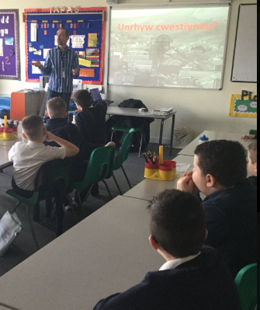  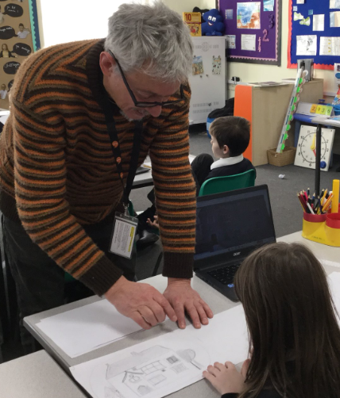  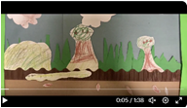  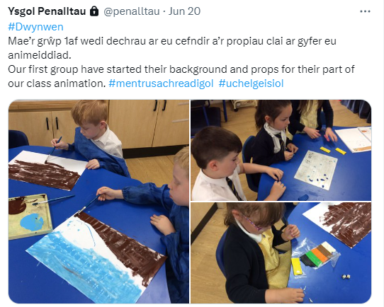 | Year 4 have now completed their Creative Lead School’s Enquiry ‘How can animation, music, and song inspire Year 4 learners to engage creatively with local history, whilst developing their literacy and expressive arts skills?’They have worked alongside musician Gareth Roberts and artist/animator Picasso Griffiths to express their research work on the history of the local area through song and animation.  The project was completely open-ended, allowing the children to truly lead the learning process. Pupils even held interviews to determine which creative practitioner was right for their project. Their work was shared with parents.  Following pupil-led research on the history and changing geography of our local area, the pupils confidently applied this knowledge; selecting key features to share in a musical animation to promote local history to learners.  We noted a huge improvement in pupils’ ability to persevere,collaborate, think ‘outside the box’, make connections, take risks and to offer suggestions and solutions. Pupil engagement improved dramatically over the course of the project, as did pupils’ confidence; particularly those pupils who usually find more academic tasks challenging. Nearly all pupils have developed their resilience and ability to tackle problems independently. Lesson observations demonstrate that nearly all pupils have become more curious and are far more willing to ask ‘What will happen if?’or ‘What if we try..’ and are able to reflect on and modify their ideas independently.  Our creative practitioners and class teacher had an opportunity to share their reflections on their work with the rest of the teaching staff.The Class teacher noted that the project had given them the confidence to let the pupils fully lead the learning, something they had previously found difficult to do, and that they had learnt several new skills associated with expressive arts. However, it was noted that co-ordinating 2 practioners and preparation or development work in between sessions was sometimes a challenge.  Staff now have a greater understanding on how to develop creativity in their own classrooms. Many of our classes have taken inspiration from the project and with support from staff involved in the Creative Lead Schools programme have made or are currently making their own animations .  The programme will be be rolled out to another class next year to enable us to share expertise and embed practice. Additional Training for staff leading the project in September.  The project received recognition in the Welsh Schools Heritage Initiative.
Priority 3:  Further develop provision for Expressive Arts  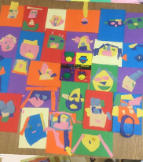  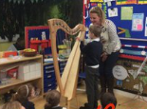  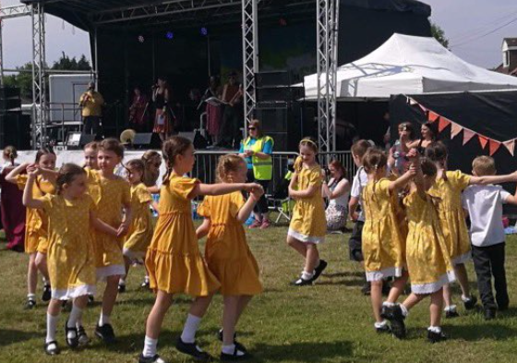  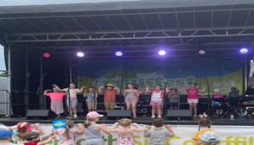  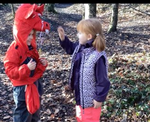  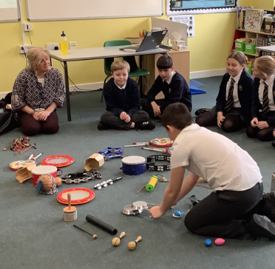 | We have returned to discrete teaching this year for some aspects of Expressive Arts to ensure adequate focus is giving to developing skills and range of media. The Arts are also highlighted in Cross-Curricular Thematic Mapping to ensure that expressive arts are interconnected with other curriculum areas e.g. Clay modelling of animals studied in science, abstract drawing in pastels to record geographical features of our local area, drama used to represent historical events such as role-play of the journey of the Mimosa to Patagonia.  Our focus during Autumn term was Art.  58% of pupils (y3-6) noted ‘ART’ as their favourite aspect of Expressive arts in our January questionnaire, with pupils noting regular opportunities to develop their art skills. Teachers also noted Art to be the aspect they most enjoyed teaching and felt confident due to experience and wide range of resources available to support their teaching. The quality of artwork is improving, and pupils are more confident in evaluating and expressing opinions. More focus is needed on vocabulary, but this is being addressed as a Cluster with the creation of an agreed graduated terminology bank.  Our after-school art clubs were very well attended. 2 pieces of artwork were placed first in the Regional Urdd Eisteddfod!  The Spring Term saw a focus on Music. Only 12% of pupils noted music as their favourite aspect of Expressive arts before this term began and staff also noted music as an aspect where they lacked confidence in teaching. All staff now have access to Charanga Cymru, an online curriculum support platform funded by WG. Training events for staff have included: Music for Beginners, An Overview of Charanga and bespoke support from Caerphilly music services. Staff questionnaires showed a 44.5% increase in staff confidence teaching music. 5.7% more pupils noted Music as their favourite aspect of Expressive Arts in our recent survey (with art still scoring highest).  Mr Rhodri Harris has been working with our Nursery staff to develop language through music and song. The pupils thoroughly enjoy these sessions and have gained so much confidence. Their language patterns have improved. The staff now have a repertoire of songs and musical activities that are being used on a daily basis.  Music certainly has a more prominent profile within the school. We competed in solo competitions in all age groups in the Urdd Eisteddfod and one of our pupils made it to Regional Final. We also competed in the parti unsain for the first time. Year 4 pupils have received whole class tuition from Caerphilly Music services in Pbuzz and Year 6 have been taught to play the Ocarina. 6 pupils are receiving additional harp lessons and are making excellent progress.  Our St David’s day celebration and class assemblies demonstrated that staff are gaining confidence in developing Music-a wide range of styles was seen in performances including folk and traditional songs (including tȏn gron/rounds), rap and pupils’ own musical creations and use of percussion instruments. Movement and dance also featured more prominently than previously.  Drama has been used frequently to explore and express learning across the curriculum. Y5/6 participated in a drama workshop run by Menter Caerffili. Re-telling and creating stories through scripted drama, puppet shows, and role-play is common practice throughout the school. One member of staff has training and experience with ‘Mantle of the Expert’ techniques, and we have begun ‘team teaching’ sessions to enable other staff to gain confidence in this technique. Our after-school Glee club gives pupils experiences in dance, music and drama. It is very well attended and the impact on pupils’ confidence has been huge. They gave a brilliant performance in Ffiliffest after only attending club just over a half term.  We have not yet had an opportunity to develop dance but are currently exploring a range of resources to support us next year. This is an area both staff and pupils noted as a subject that they did not feel confident in or enjoy. We will continue to work on improving this.
Priority 4  To promote pupils’ spiritual, moral, social and cultural development and ensuring our provision covers mandatory elements of relationships and sexuality education (RSE) and religion, values and ethics (RVE) as outlined in CFW  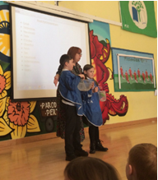 | Our Well-being Lead and Pastoral lead met with Healthy Schools team to discuss and review our current provision. We are confident that the Jigsaw Programme is in line with What Matters Statements within the H+W AOLE and the RSE Code. Our Thematic Plan further enhances Jigsaw Programme and provides pupils with real-life contents and opportunities to make connections in their learning. An introduction to Jigsaw was delivered to governors.  Workshop held for parents to discuss H+WB (including RSE) Unfortunately, this was not well-attended. Further literature is being prepared to help parents understand our Health and Well-being provision (including RSE) and will be shared in September.Humanities lead and HT met with EAS Humanities and RVE to discuss curriculum design and have held individual discussions with the Humanities lead for Ysgol Gyfun Cwm Rhymni and are working with our Cluster schools to develop a shared understanding of progression in vocabulary in each AOLE. We have completed a curriculum review to ensure that our curriculum design and thematic mapping plan encompasses RVE disciplinary lenses and journeys, not only through the Humanities but other AOLEs and school activities. Current thematic plans are being reorganised into Whole school themes, with substantive concepts such as Identity,Conflict, Sustainability and Authority being explored and developed throughout the school.  We have compiled a bi-annual assembly map which feeds into our thematic work (class and whole school/ phase)- Assemblies include a focus on monthly ‘Values’ promoted through stories from all religions and cultures and explore RVE lenses and Wellbeing themes.
Priority 5-  Ensure shared understanding of progression and assessment (Cluster) | Cluster Engagement in Impact Wales training ‘Progression + Assessment has been extremely valuable and has led to a great deal of professional dialogue within our Cluster on agreed understanding of progression and assessment strategies.  Assessment should be “ an ongoing process that is indistinguishable from teaching and learning and an essential and natural part of the teaching process and not an additional bolt on’ (Donaldson, 2015) Our revised planning breaks down the skills and knowledge that enable pupils to achieve WM statements (along progresion steps) within each AOLE down into smaller Stepping Stones or Cerrig Troedio in the context of our own individual, unique local curriculum. This planning structure will help staff to assess pupils progress within lessons and across a series of lessons. Formative assessment strategies are regularly discussed as part of our Professional Learning Programme.  An agreed discription of progression expectations has been passed (both as a school and Cluster) and termly trackers are in place which colour code effort, achievement and progress. School based termly Moderation sessions are held to ensure consistency in expectations and shared understanding of progression. Senior leaders hold discussions with staff about any individuals causing concern and strategies for improvement/support are agreed. At present we are currently tracking Language and Mathematics but will be expanding this to include general wellbeing and AOLEs.  Cluster Professional dialogue meetings have been held in each Year group to ensure a shared understanding of expectation and progression for each year group. A great deal of good practice was shared. Cluster Assessment Policy has been agreed- governors to discuss adopting this policy, along with school specific annexes in September.  We have trialled Pupil-Led Progress Meetings during the Summer Term and hope to further build on this next year.

School Development Targets 2023-24
- Reading – enable staff, learners and parents to have a clear understanding of progression in reading whilst ensuring reading for pleasure is our main driver.

- Assessment and tracking - Sharing Progress with all stakeholders (including formative assessment with pupils) -including ‘on-entry’ baseline assessments.
- Further improve pupils’ digital skills
- Introduce the Whole school Approach to Wellbeing and Mental Health Framework
The school’s prospectus is updated annually and is available to all on the school’s website.

School Contact Information
Chair of Governors: Kate Grindal (c/o Ysgol Gymraeg Penalltau)
Head teacher: Mrs Andrea Woods, Ysgol Gymraeg Penalltau
Cwm Calon Rd, Penallta, Caerphilly, CF82 6AP
Telephone – 01443 862974 E-Mail: ysgolpenalltau@sch.caerphilly.gov.uk
Other Contact Details
Caerphilly County Borough Council – Local Education Authority
Director of Education and Leisure - Mrs. K Cole, Tŷ Penallta, Tredomen Telephone (01443 815588) www.caerphilly.gov.uk

